Module 2: Baseline Assessment

Session 5: MArket Assessment

Handout 1 - Market Exercise

What items and services do different wealth groups buy and sell at village, regional and urban level?
First of all, think about (i) the baseline livelihood strategies that are employed by households and (ii) their expenditure patterns. You might find it useful to think back to what was discussed in previous sessions, especially on Baseline Livelihood Strategies. Fill in the simple table below, listing the items and services bought and sold by poorer and richer households. Don’t restrict yourself to one livelihood zone - try and think of as many different contexts as you can (agricultural, pastoral, coastal…).

Items and services bought and sold
 | Poorer households | Richer households
Selling
Buying

Linkages between households and sources of demand and supply
Now, try and fit the items and services in the table above into the diagram below:
    - For items or services that people are selling, think about the source of demand and record the link on the diagram below as in the ‘food crops’ example.
    - For items or services that people are buying, think about the source of supply and record the link on the diagram below as in the ‘household goods’ example.
    - Also include transactions that may not be undertaken directly for money (gifts) and transactions within a household (remittances).

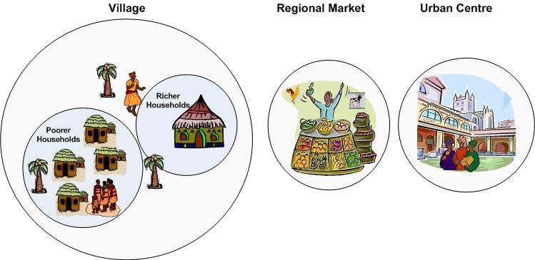
Food crops
Household goods

- You have been told that middle households in a particular livelihood zone run out of their own food about eight months after the harvest. They usually manage to produce and sell about three sacks of cotton. They also earn cash through agricultural labour, selling one or two goats, and selling firewood.

What prices should you check during a market visit which would be useful for finding out or cross checking:

- How much cash middle households are able to earn? and
- How much food that cash would buy?

- You are in a livelihood zone in which tobacco production is an important source of income for middle and better off households. All wealth groups buy maize at some point during the year.

What simple question(s) would you need to ask traders in order to understand what households are vulnerable to in terms of market change or disruption?

